**Project Deliverable 4a**

**Defined Unit Tests to Create:**

* Adding Product
  + A new product is added correctly
  + A product needs to be added when it exists
  + A product needs to be added when it is full
* Removing Product
  + A product in the customers shopping cart is removed
* Getting Total
  + Is the amount a valid amount (not a negative amount)
  + Should return the correct amount
* Getting Product
  + Does it return the correct item

**Tests**

**First AddProduct test passed:**

**Second AddProduct test passed:**

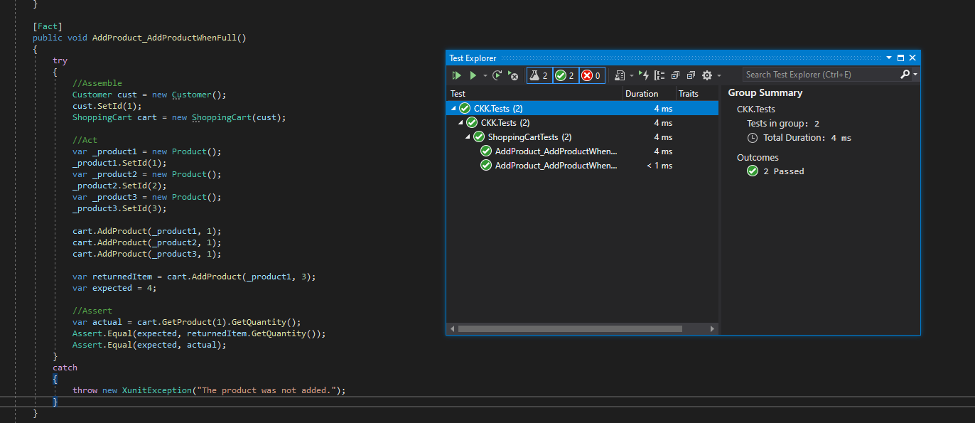

**RemoveProduct and GetTotal tests passed:**

